IE 311 — Operation Research 1
Linear Programming Formulation Problems

- A furniture maker has 6 units of wood and 28 hours of free time, in which he will make decorative screens. Two models have sold well in the past, so he will restrict himself to those two. He estimates that model I requires 2 units of wood and 7 hours of time, while model II requires I unit of wood and 8 hours of time. The prices of the models are $120 and $80, respectively. How many screens of each model should the furniture maker assemble if he wishes to maximize his sales revenue?
x₁: # of model 1 to be produce.
x₂: # of model 2 to be produce.
Maximize Z = 120 x₁ + 80 x₂
Subject to: 2x₁ + x₂ ≤ 6
7x₁ + 8x₂ ≤ 28
x₁, x₂ ≥ 0 & integer

- A company has three operational departments (weaving, processing, and packing) with capacity to produce three different types of clothes namely suiting, shirting and woolen yielding a profit of $2, $4 and $3 per meter respectively. One meter of suiting requires 3 minutes in weaving, 2 minutes in processing and 1 minute in packing. Similarly one meter of shirting requires 4 minutes in weaving, 1 minute in processing and 3 minute in packing. One meter of woolen requires 3 minutes in each department. In a week, total run time of each department is 60, 40 and 80 hours for weaving, processing, and packing respectively. Formulate this problem as a linear programming model and solve.
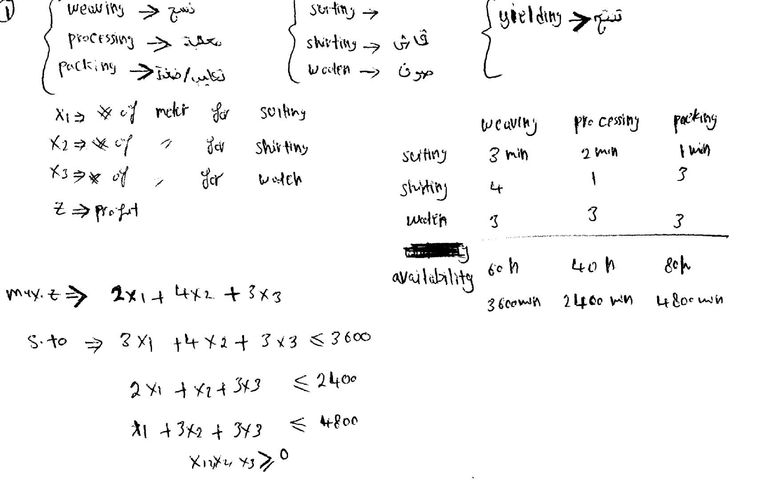

- A manufacturing company engaged in producing three types of products: A, B and C. the production department daily produces component sufficient to make 50 units of A, 25 units of B and 30 units of C. The management is confronted with problem of optimizing the daily production of products in assembly department where only 100 man-hours are available daily to assemble the products. The following additional information is available.
Type of product | profit contribution per unit of product ($) | Assembly time per product (hrs)
A | 12 | 0.8
B | 20 | 1.7
C | 45 | 2.5
The company has a daily order commitment for 20 units of product A and total of 15 units of B and C products. Formulates this problem as an LP model so as to maximize the total profit.
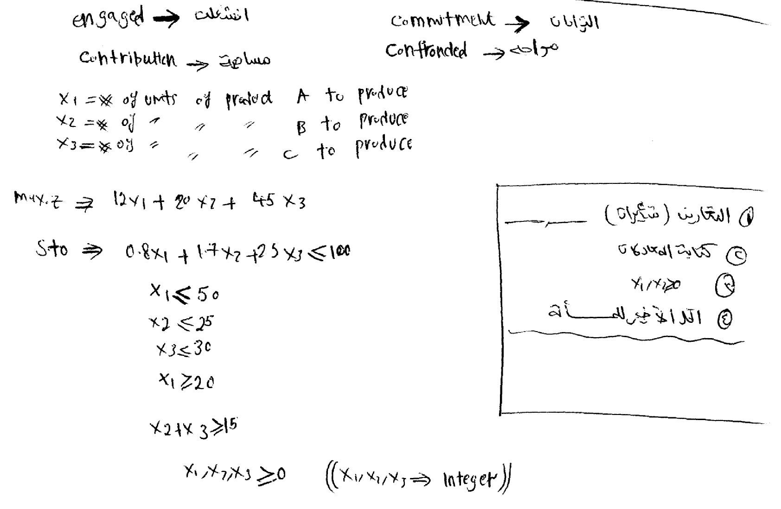

- A co. produces 3 types of products: A, B & C; with profits of 6, 10 & 27 Saudi Riyal respectively; the assembly time per product is 2, 3 & 5 hours, respectively. The daily production capacity is sufficient to make (100 units of A), (50 units of B) & (60 units of C). Only 480 man-hours are available daily to assemble the products. The daily demand is (40 units of product A) & (total of 30 units of B &C products). The number of units produced from type B should not be more than the number of units of type A. Formulate this problem as an LP model so as to maximize the total profit.
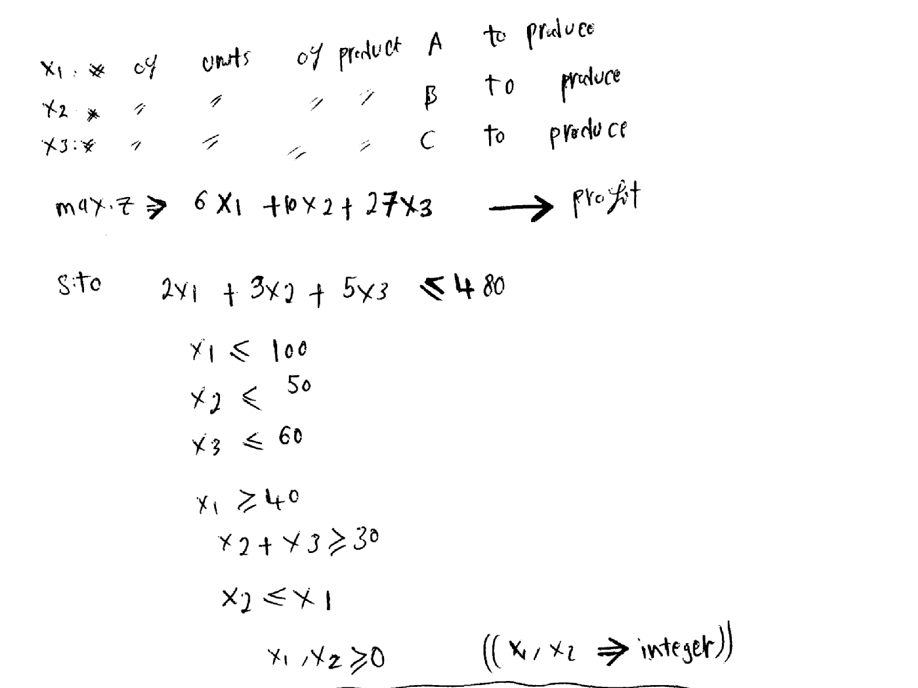

- A water Co. has 3 bottling machine A, B, & C; these machines are designed for Small, Medium & Large bottles. However each Machine can be used on all sizes with some loss of efficiency. The manufacturing data is as follows:
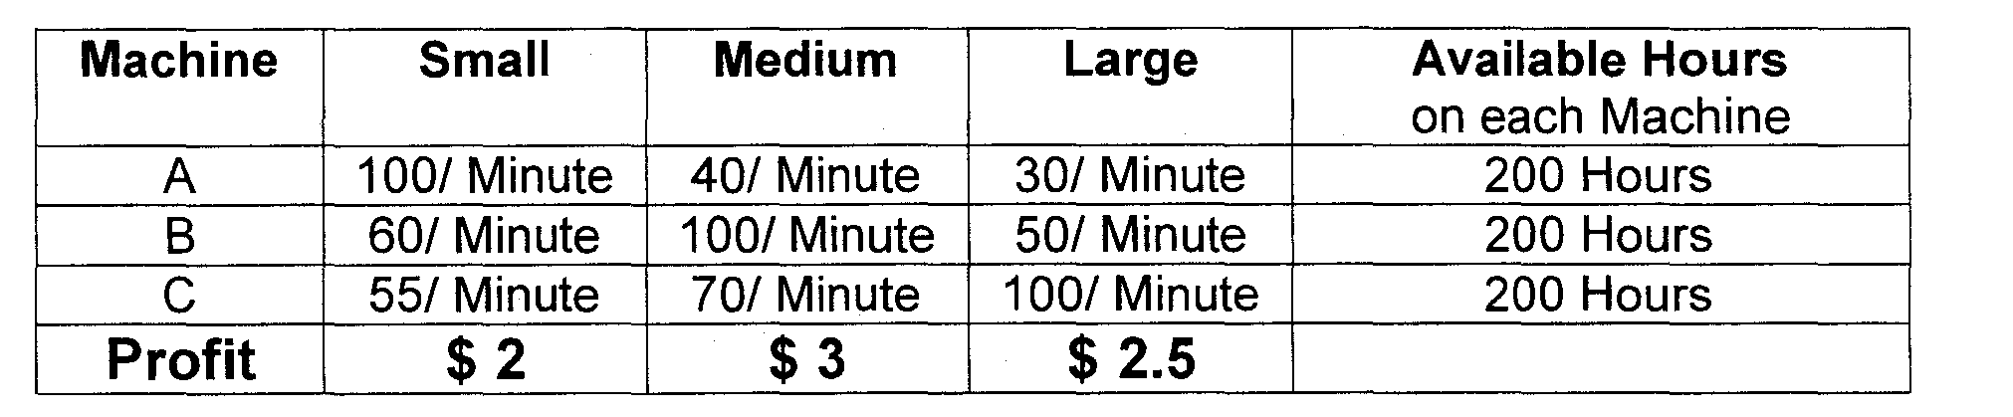
Total production can not exceed 500,000 bottles from all sizes and the market can absorb 125,000 for Small bottles 70,000 for Medium & 100,000 for Large bottles. Formulate this problem as an LP model in order to maximize total profit.
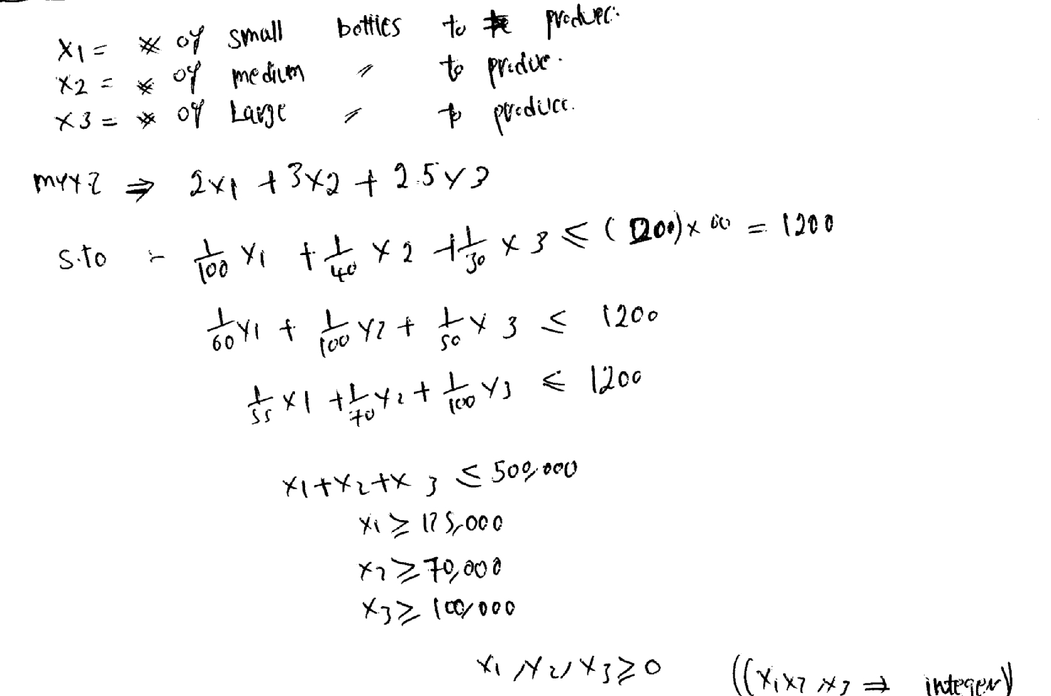

- Glass Manufacturing Store is opening a new department with a storage area of 10,000 m2. The manager is considering four products for display.
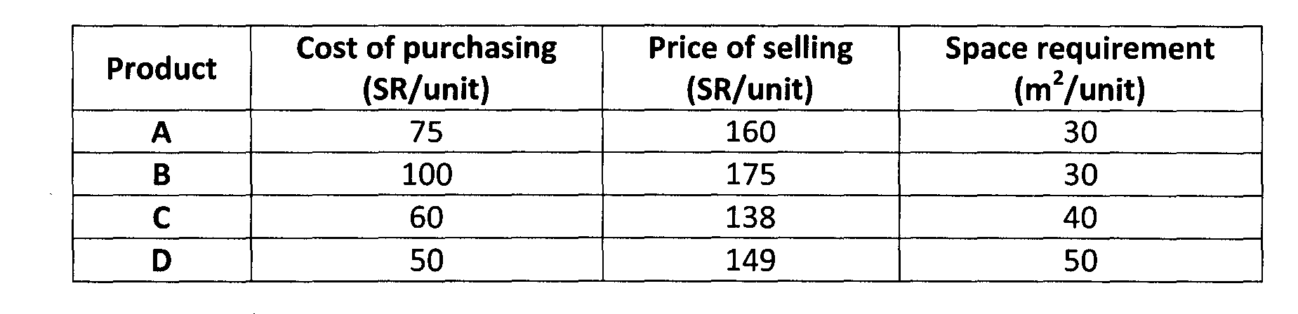
The company has SR 50,000 available for purchasing the products, It is required that at least 10 units of each product are on display but no more than 100, 90, 70, 90 for products A, B, C and D respectively. Formulate the problem of finding the maximum profit gained from the displayed products. Assume all displayed products can be sold.
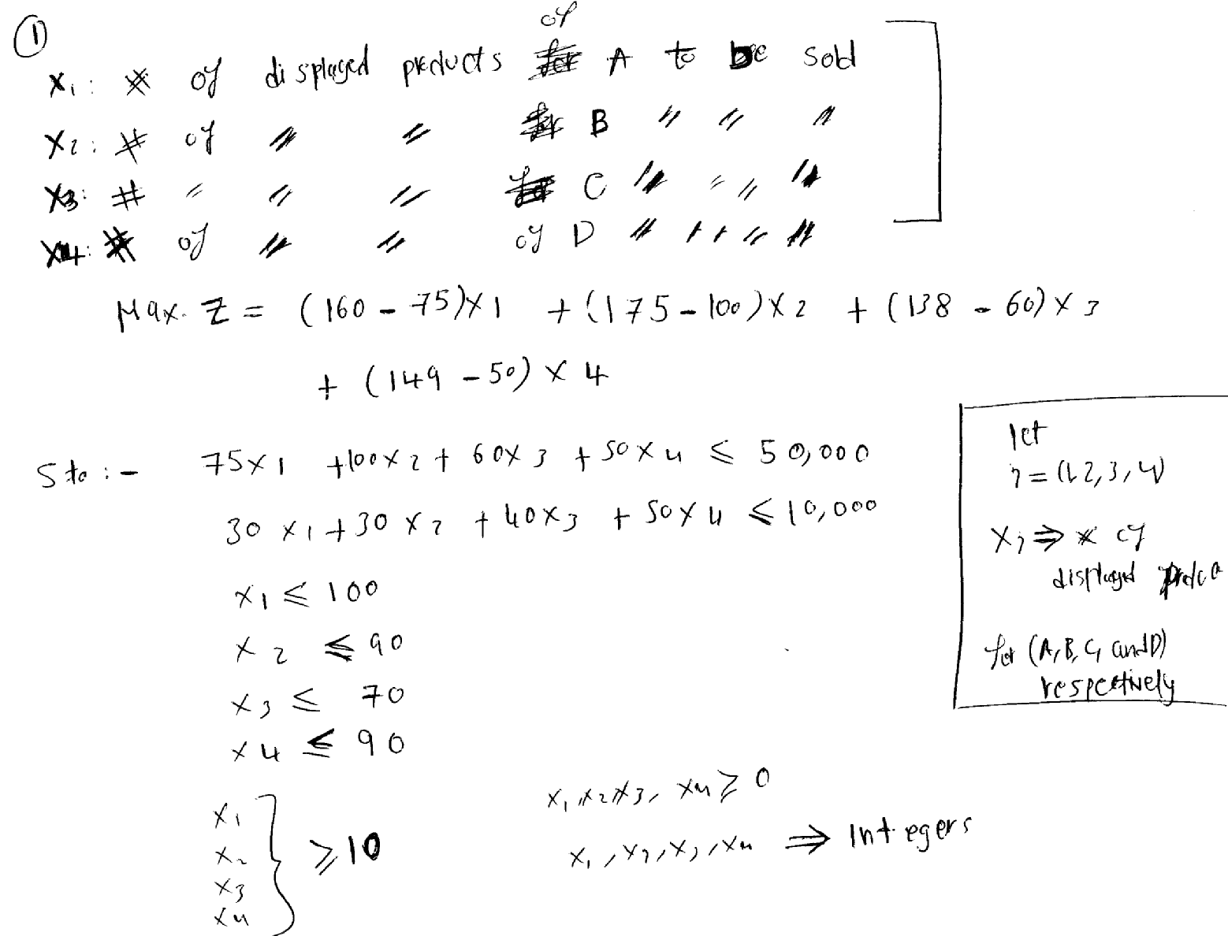

- Four chemicals are produced, 3 main products (A, B & C) and by-product (D) [product (D) is a by-product of product (A)]. Their profits are $6, $7, $8 and $4 per unit respectively. The demand for product (D) is less than 40 units. Extra units from product (D) are destroyed for a cost of $0.5. The ratio of product (D) to that of product (A) is 5:1.
Products (A, B & C) take machining times 5, 4 & 8 hours on Machine 1 and take machining times 7,6 & 9 hours on Machine 2 (Note: product (D) is a by-product of product (A) - it has no machining time). The available times for machines 1 & 2 are 200 and 300 hours. Formulate this problem as a linear programming model to maximize the total profit.
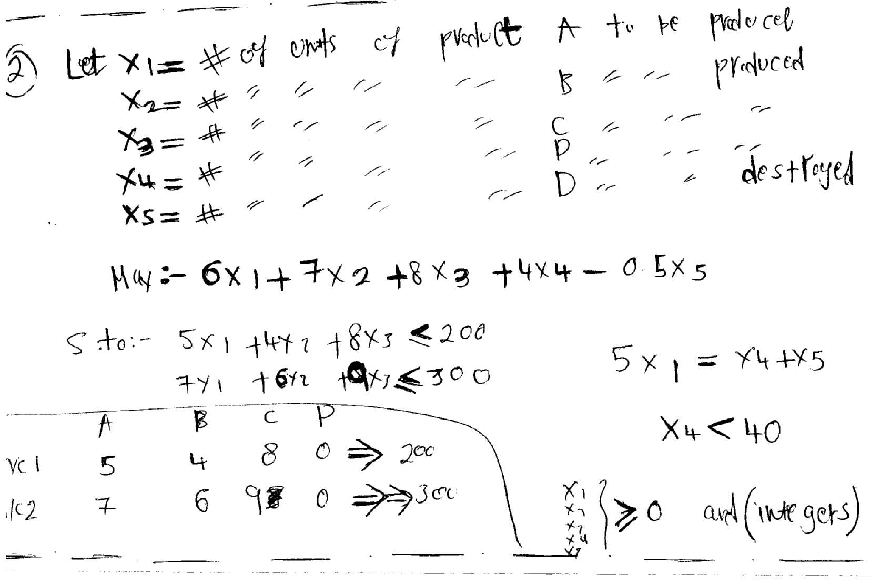

- A company is attempting to decide the mix of products which it should produce next week. The following table shows the requirements needed: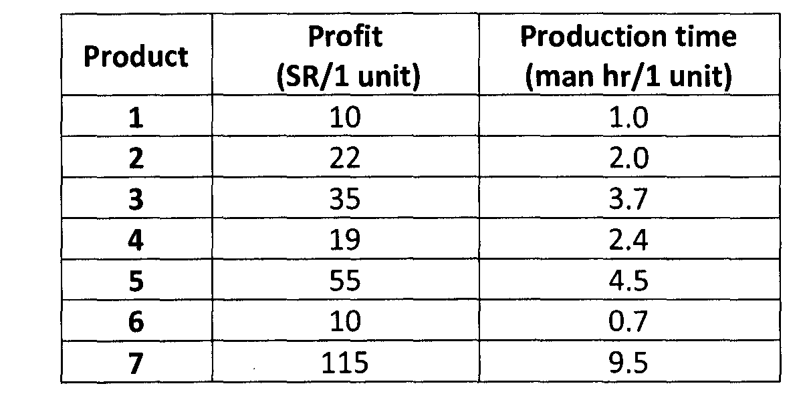
Suppose that all items produced are sold. The company has 720 man-hours available next week. 1-Formulate this problem of finding the maximum profit as an LP.
2-Suppose that:
- If any of products of type 7 are produced, an additional fixed cost of SR 2,000 is incurred.
- Suppose that: If 50 or more of product type 3 are produced, additional man hours of 10 are added.
Formulate this problem of finding the maximum profit as an LP.
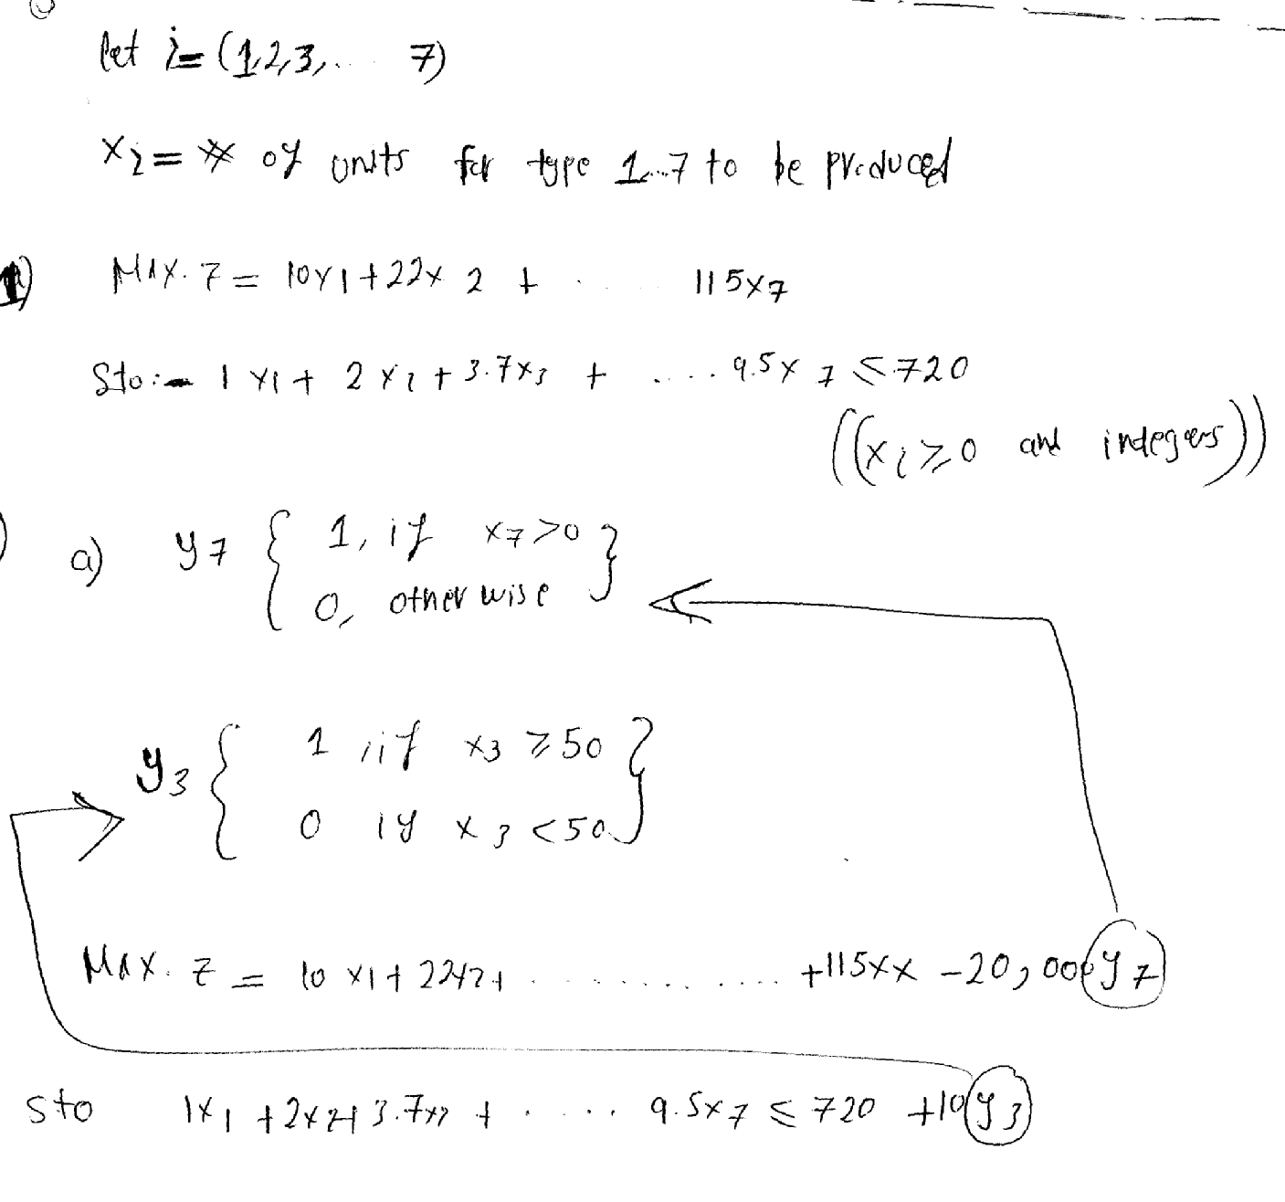

- Doctors work 8 consecutive hours. The demand for doctors is as follows:
Hospital Hours | 00-4am | 4am-8am | 8am-Noon | 12-4pm | 4pm-8pm | 8pm-midnight
Demand for doctors | 15 | 10 | 60 | 35 | 60 | 50

Formulate an LP model to minimize the number of doctors employed by the hospital.
xi = # of doctors to do their duty in 6 period (8 hours consecutive) respectively
Where i = {1, 2, 3…..8}
Min. Z = x₁ + x₂ + x₃ + x₄ + x₅ + x₆
Subject to: x₁ + x₂ ≥ 10 x₄ + x₅ ≥ 60
x₂ + x₃ ≥ 60 x₅ + x₆ ≥ 50
x₃ + x₄ ≥ 35 x₆ + x₁ ≥ 15 x_{i} ≥ 0 & integer.

- Consider the following problem faced by a production planner in a soft drink plant. He has two bottling machines A and B. Machine A is designed for 8-ounce bottles and machines for 16-ounce bottles. However, each can be used on both types with some loss of efficiency. The following data is given.
Machine | 8-ounce bottles | 16-ounce bottles
A | 100/minute | 40/minute
B | 60/minute | 75/minute

Each machine can be run 8-hours per day, 5 days per week. Profit on a 8-ounce bottles is 25 halalas and on a 16-ounce bottles is 35 halalas. Weekly production of the drink cannot exceed 30,000 ounces and the market can absorb 25,000 8-ounce bottles and 7,000 16-ounce bottles per week. The planner wishes to maximize his profit subject to the production and market constraints. Formulate the problem as a LP model.
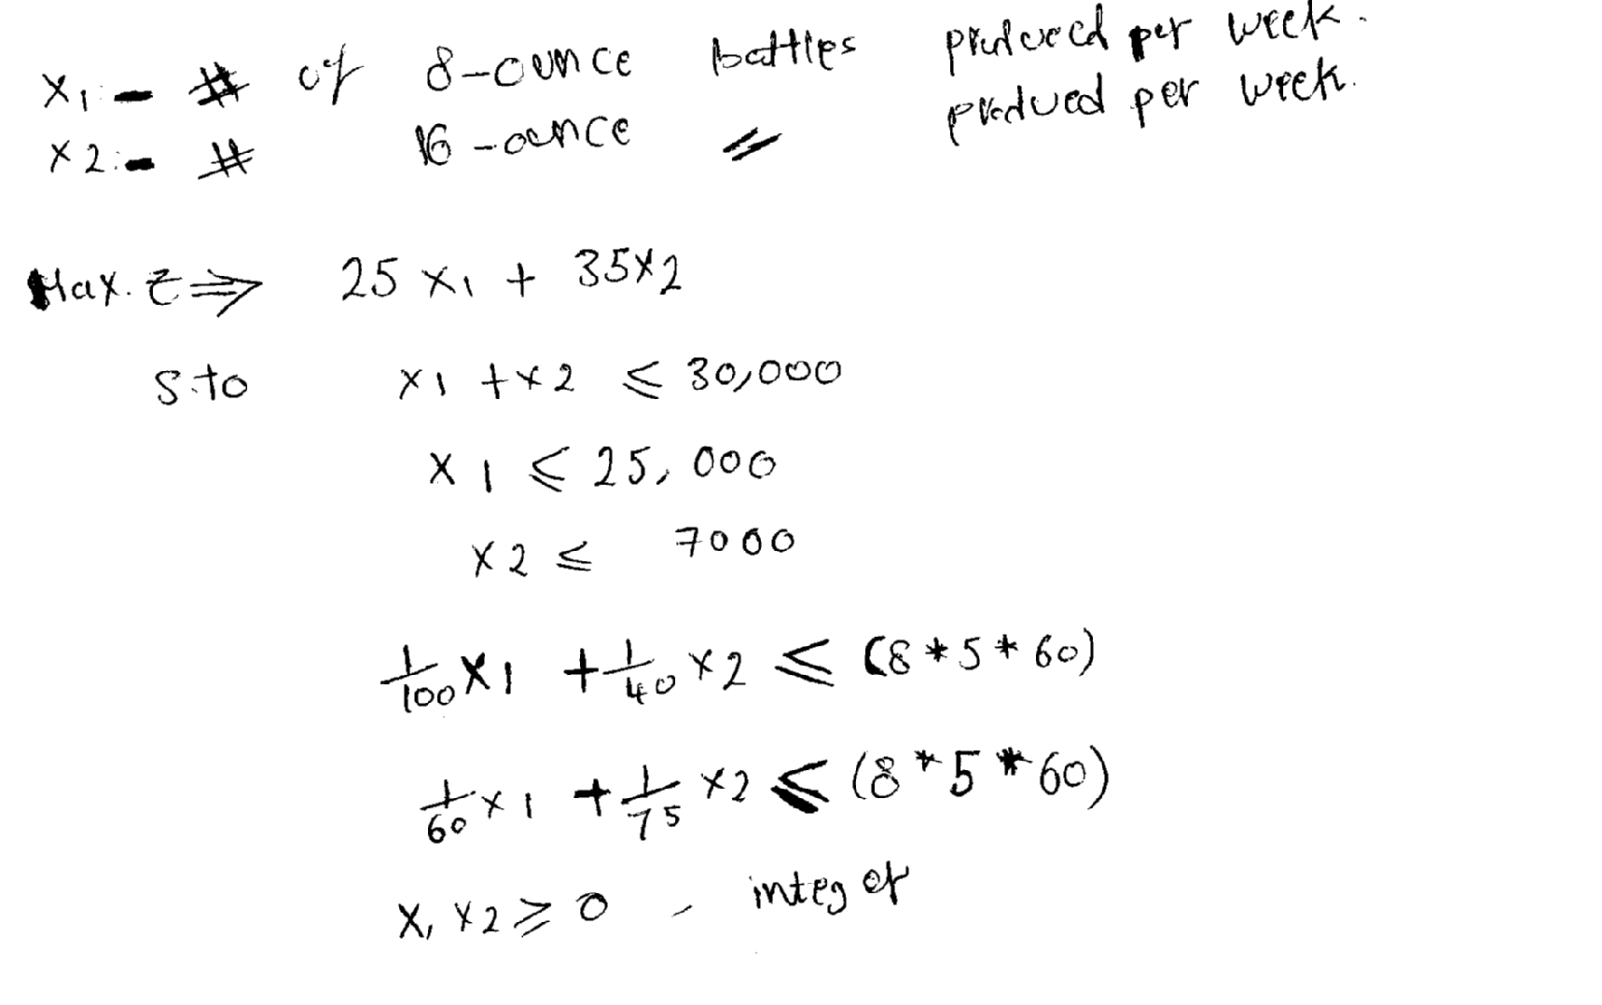

- A company produces toys; it has 100 trained workers each of them produces 2 toys/day. The company wants to add 60 workers in phases, over the next 7 days.
- The new workers need 2 days training. Every old worker can train 3 new workers.
- Assume no production from trainers & trainees during training period.
- Trainees get the same rate as for the trainers (80 $R per day).
The demand for toys (in the next 7 days) is: 180, 180, 200, 215, 300, 299 and 320 respectively. Formulate a LP model to develop a training schedule that minimizes the total workers (for all workers) cost (in $R) over the 7 days.
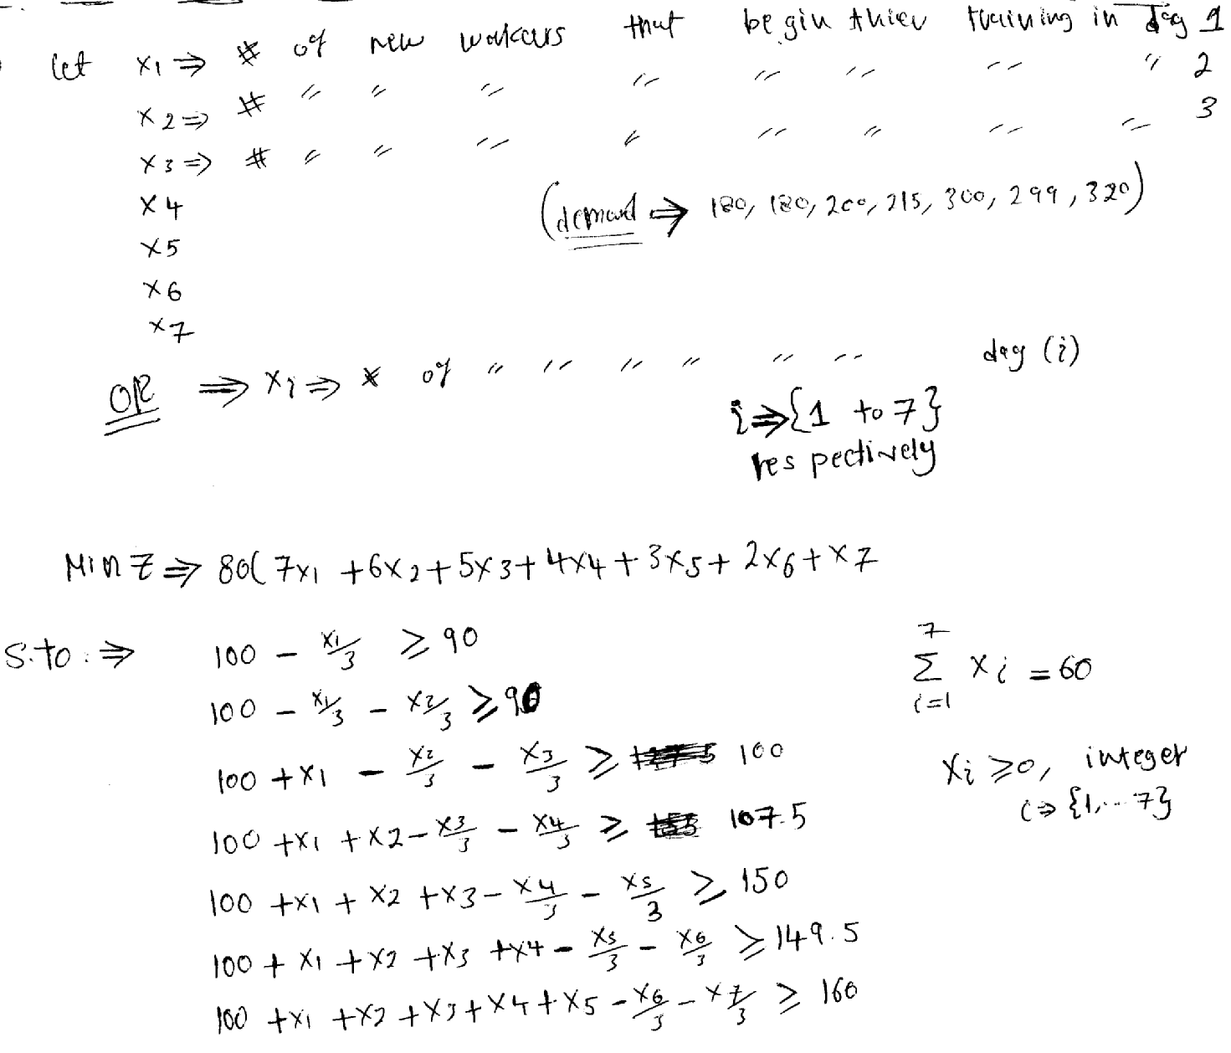

- A furniture manufacturing company produces tables and chairs. Each table generates a profit of $80 and requires 3 hours of assembly time and 4 hours of finishing time. Each chair generates $50 of profit and requires 3 hours of assembly time and 2 hours of finishing time. There are 360 hours of assembly time and 240 hours of finishing time available each month. Formulate this problem as an LP model.
Let x₁ = # of tables to be produce.
x₂ = # of chairs to be produce.
Max. z = 80 x₁ + 50 x₂
S.to: 3 x₁ + 3 x₂ ≤ 360
4 x₁ + 2x₂ ≤ 240
x₁ and x₂ ≥ 0 & integer.

- The White Window Company is a company with only three employees which makes two different kinds of hand-crafted windows a wood-framed and an aluminum-framed window. They earn $60 profit for each wood-framed window and $30 profit for each aluminum-framed window. Doug makes the wood-framed, and he can make 6 per day. Linda makes the aluminum frames, and she can make 4 per day. Bob forms and cuts the glass, and he can make 48 square feet of glass per day. Each wood-framed window uses 6 square feet of glass and each aluminum-framed window uses 8 square feet of glass. The Company wishes to determine how many windows of each type to produce per day to maximize total profit. Formulate this problem as an LP model.
Let x₁ = # of wood-framed window to be produce.
x₂ = # of aluminum-framed window to be produce.
Max. z = 60 x₁ + 30 x₂
S.to: x₁ ≤ 6
x₂ ≤ 4
6 x₁ + 8 x₂ ≤ 48
x₁ and x₂ ≥ 0 & integer.

- Electronics Company produces three types of parts for automatic washing machine. It purchases casting of the parts from a local foundry and then finishes the part of drilling, shaping and polishing machines. The selling prices for each unit of A, B and C are SR 8 SR 10 and SR 14. All parts made can be sold. Castings for each part of A, B and C respectively cost SR 5, SR 6 and SR 10. The shop possesses only one of each type of machine. Costs per hour to run each of the three machines are SR 20 for drilling, SR 30 for shaping and SR 30 for polishing. The capacities (parts per hour) for each part on each machine are given below in the table:
Machine | Capacity per hour
Machine | Part A | Part B | Part C
Drilling | 25 | 40 | 25
Shaping | 25 | 20 | 20
Polishing | 40 | 40 | 40

The management of the shop wants to know how many parts of each type it should produce per hour in order to maximize profit for an hour’s run. Formulate this problem as an LP model.
Let x₁ = # of unit of A to be produce.
x₂ = # of unit of B to be produce.
x₃ = # of unit of C to be produce.

Profit of one Part of A = 8 – [5 + 20/25 + 30/25 + 30/40] = 0.25
Profit of one Part of B = 10 – [6 + 20/40 + 30/20 + 30/40] = 1.25
Profit of one Part of C = 14 – [10 + 20/25 + 30/20 + 30/40] = 0.95

Max. z = 0.25 x₁ + 1.25 x₂ + 0.95 x₃
S.to: x₁/25 + x₂/40 + x₃/25 ≤ 1
x₁/25 + x₂/20 + x₃/20 ≤ 1
x₁/40 + x₂/40 + x₃/40 ≤ 1
x₁ , x₂ and x₃ ≥ 0 & integer.

- A factory produced 8 kinds of products as below:

Product Type | 1 | 2 | 3 | 4 | 5 | 6 | 7 | 8
Profit $ | 1 | 1 | 1 | 2 | 2 | 3 | 3 | 3
Capacity | 120 | 30 | 40 | 120 | 30 | 40 | 120 | 30

- Formulate it as LP Problem.
- Product type-1 takes on values of {0,21,27 , range (32-50) , range (61-70)}
- Product type-3 should not be produced if type-8 is produced & they are not produced together.
- If both type 6 & type 7 are produced then type-8 must be produced.
- Type 4 & 5 use the same machine (machine costs $ 50,000). If the machine is on it produced both types; if it is off none of the two is produced.

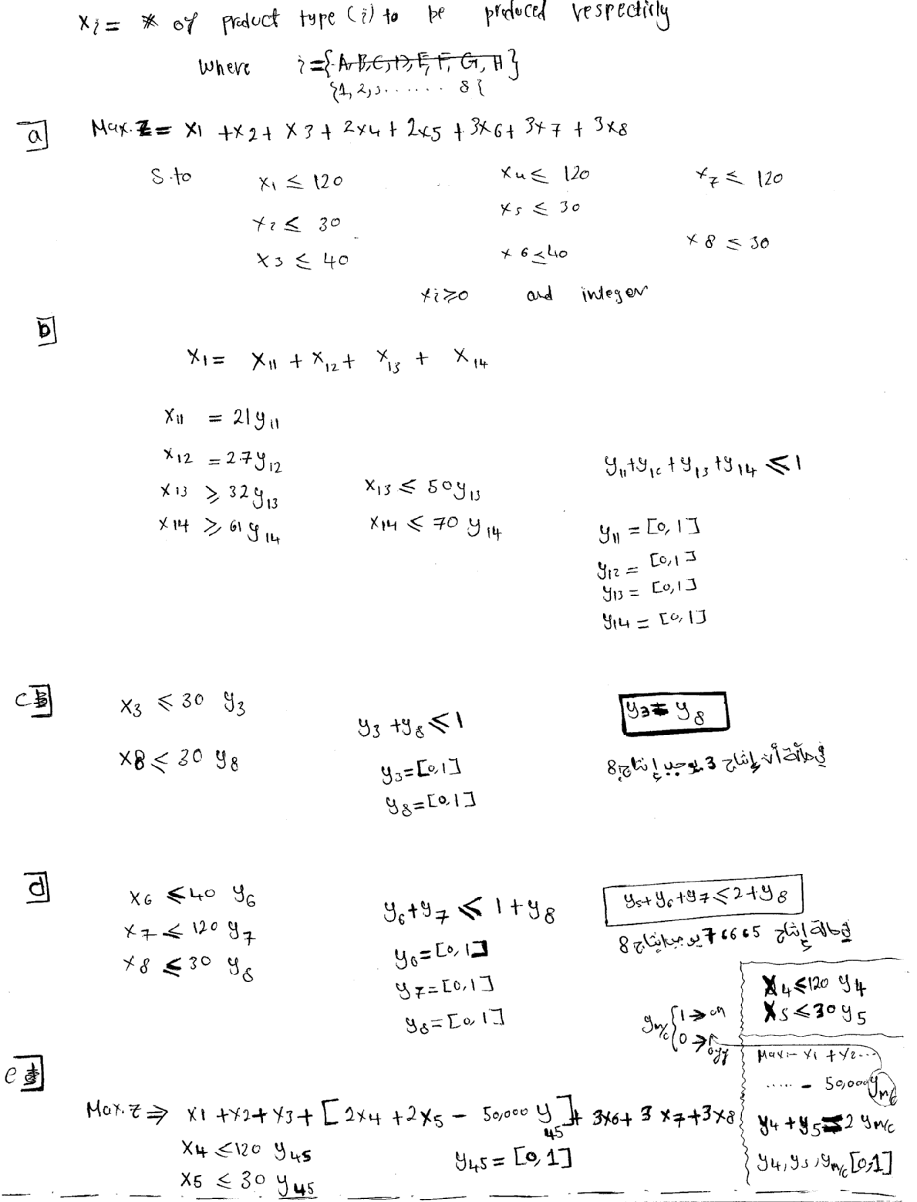

- A co. produced crude oil from 8 potential wells. The data is as follows:

Well No. | 1 | 2 | 3 | 4 | 5 | 6 | 7 | 8
Profit (in Millions) / Barrels | 1 | 1 | 1 | 2 | 2 | 3 | 3 | 3
Capacity (Millions of Barrels) | 20 | 200 | 20 | 40 | 40 | 70 | 70 | 70
Drilling Cost (in Millions) | 11 | 22 | 33 | 44 | 55 | 66 | 77 | 88

- Formulate it as LP Problem.
- Well No-1 produce (0, 3, 8, 19) Millions of Barrels.
- Well No-2 produce {0, 21, range (32-50), range (61-170)} Millions of Barrels.
- Well No-3 should not produce any if Well No-8 is producing & they cannot produces together.
- If both Well-6 & Well-7 produce then Well-8 must also produce.
- Well-4 & 5 Share common Equipments (Equipments costs $ 506,000) if the Equipments is on it produced both; if it is off nothing is produced.

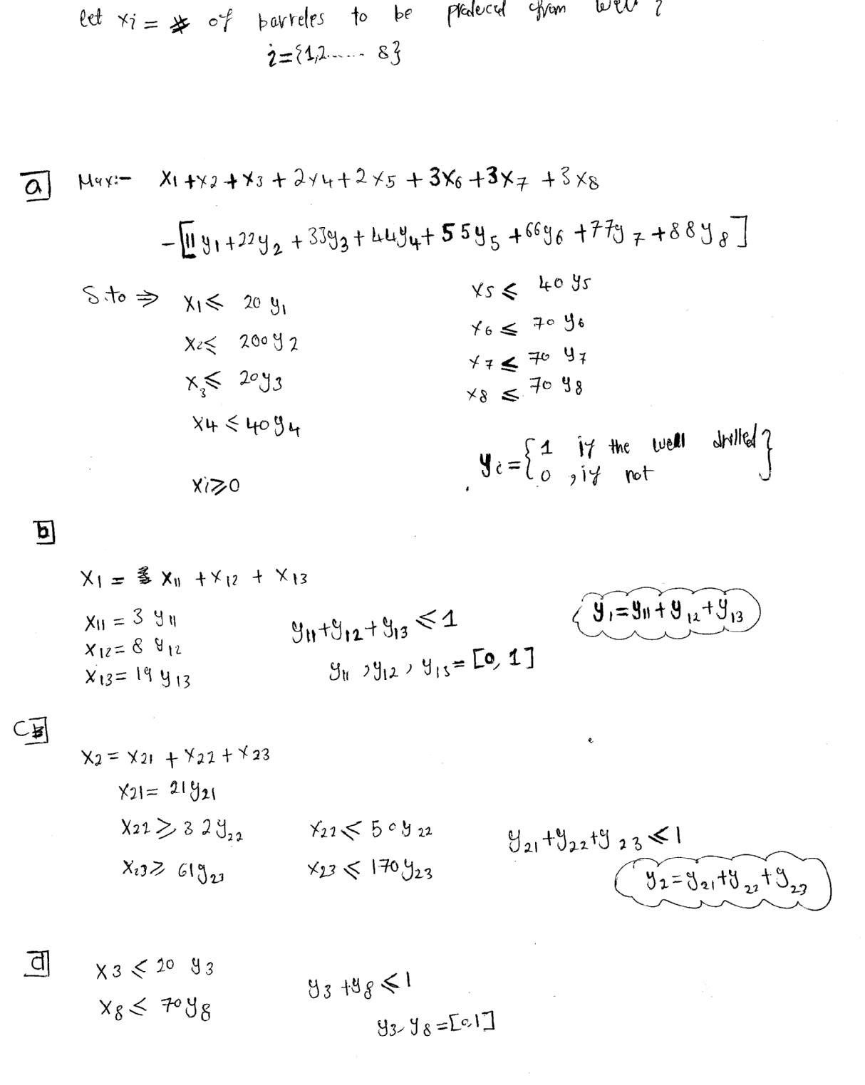

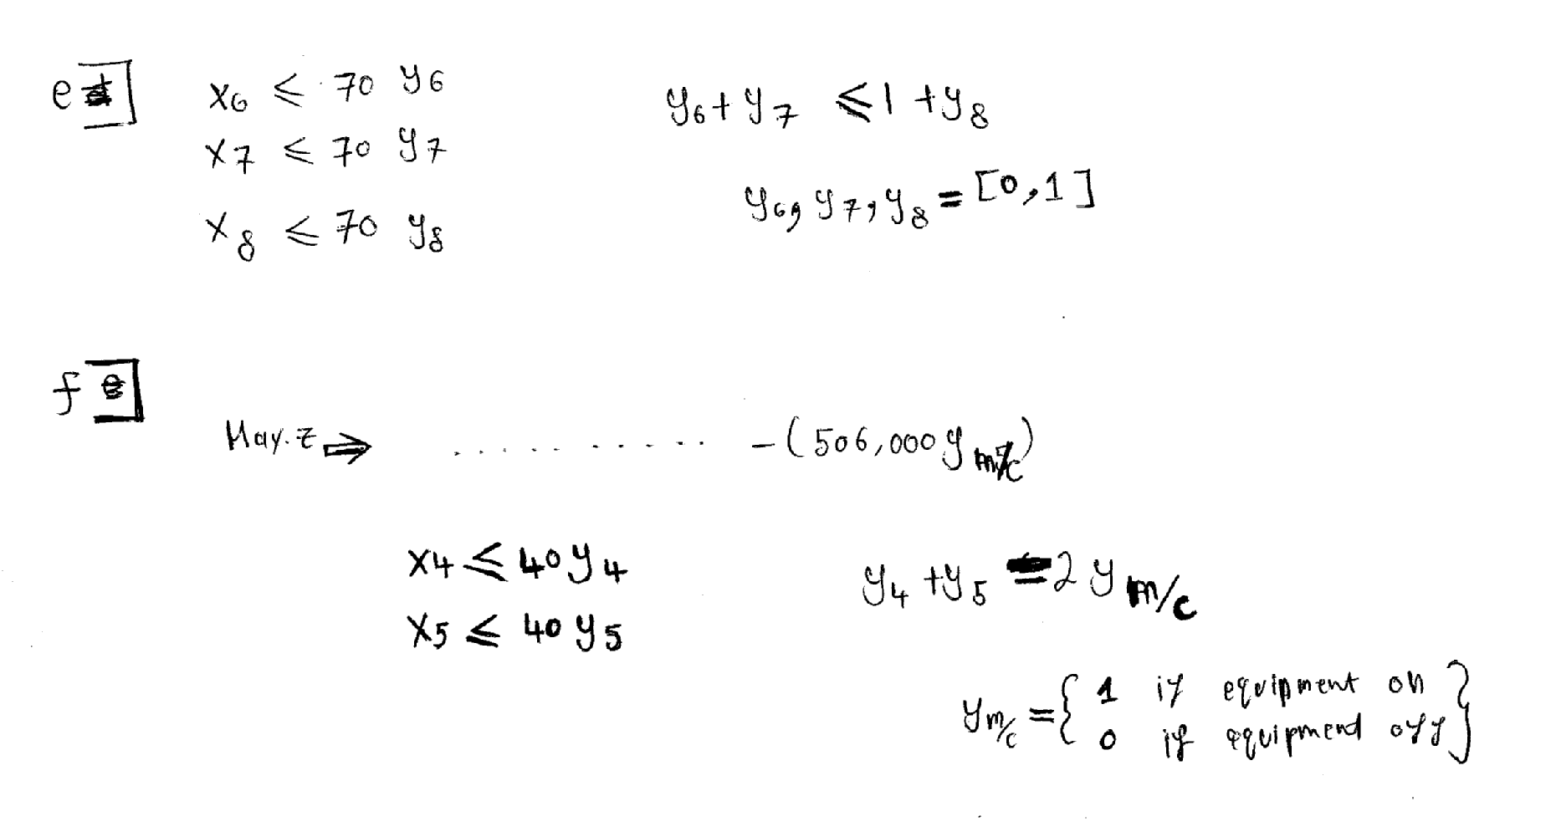

- Planning (Product & Service):
A hospital requires the proper combination for 2-meals (lunch & dinner). Use the data below to formulate this problem as a single L.P. model applying all conditions below:

Food Type | Chicken | Lamb | Fish | Orange Juice | Apple Juice | Milk | Rice | Potato | Limit per meal
Price/Kg | 1 | 2 | 3 | 0.4 | 0.5 | 0.6 | 0.07 | 0.08 | Limit per meal
Calories  (x 100) | 1 | 1 | 1 | 2 | 2 | 2 | 3 | 3 | 100
Acidity Level | 4 | 4 | 4 | 5 | 5 | 5 | 6 | 6 | 200
Availability | 20 | 20 | 20 | 50 | 50 | 50 | 70 | 70

a) A meal must have one-and-only-one type from each group (i.e. one kind of meat, one kind of drink and one type of carbohydrate).
b) Milk should not be served with fish at any time.
c) The same type of food should not be served at both meals.
d) If milk is serve it must be in the range of (0.4 - 0.88) or (1 - 2.2) or (3- 4.4).

The solution: xij = # of units to produce from food type i to be served at meal
i = {1, 2, 3 ….8} j = {1, 2}
